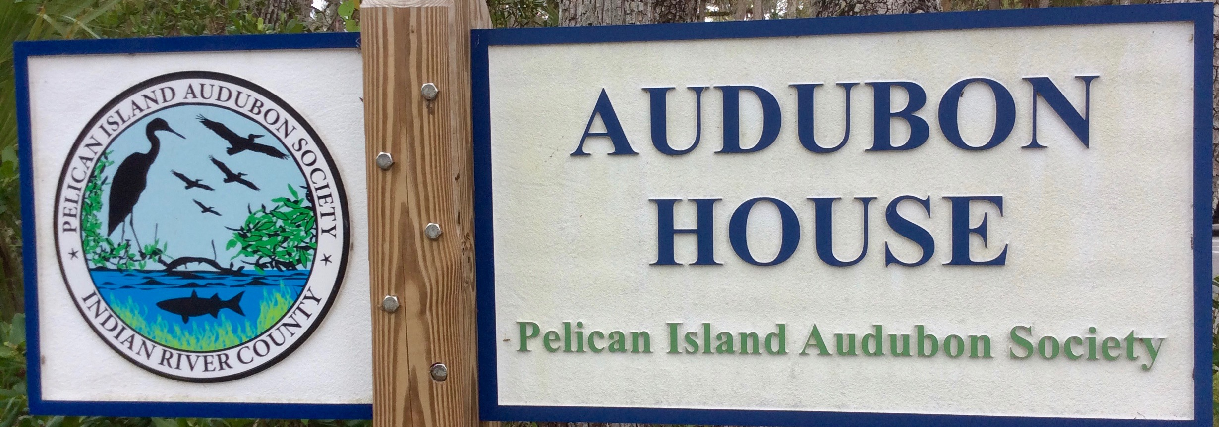
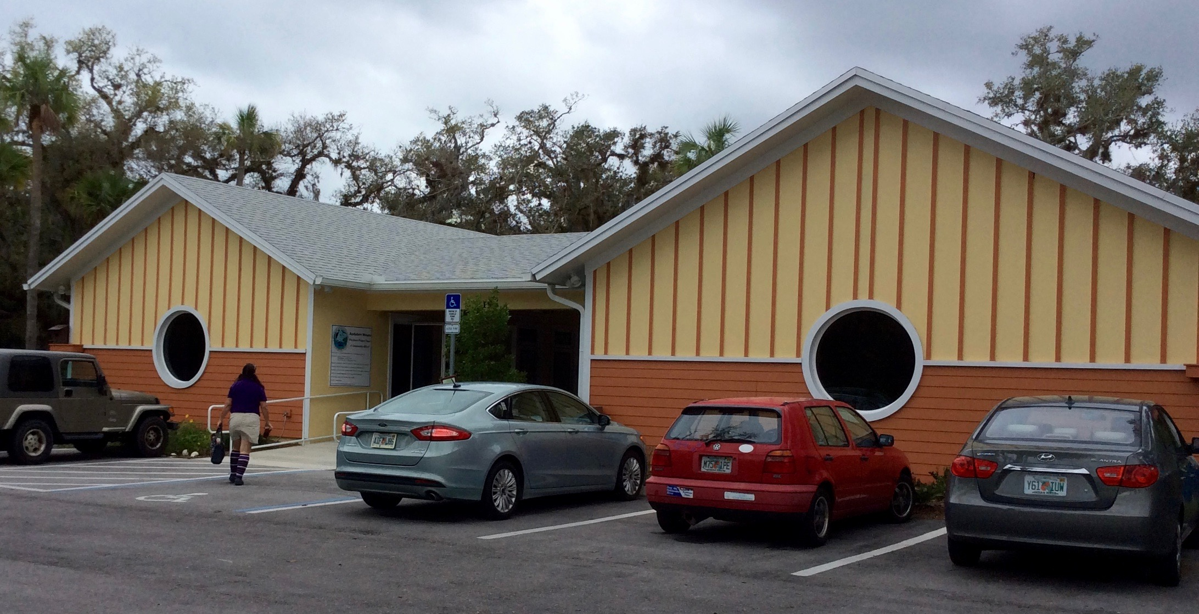

AAUW Vero Beach Annual Meeting, Election and Program
April 22, 2017, 1:30 – 3:00 pm
Audubon House
195 9th Street (Oslo Rd. East), Vero Beach

Program:

Annual Report from the President
Election of Officers for 2017-18
Refreshments
Dr. Juanita Baker, Exciting Birds in Our Area

Please wear casual clothes and allow time for a walk on one or two walking trails—the Oslo Riverfront Conservation Area (ORCA) that goes out to the lagoon, or the South ORCA Scrub Trail behind the Audubon House. Maps provided!

